 | 12.1.10 Editors - Geometry Nodes Editor - Header - Add Menu - Geometry
Table of content
Detailed table of content 1
Add menu - Geometry 4
Bounding Box 4
Convex Hull 4
Delete Geometry 5
Geometry to Instance 5
Geometry Proximity 6
Join Geometry 6
Raycast 7
Separate Components 8
Separate Geometry 9
Transform 10
Set ID 10
Set Position 11
Legacy - Geometry 11
Delete Geometry 11
Raycast 12

Detailed table of content
Detailed table of content
Detailed table of content 1
Add menu - Geometry 4
Bounding Box 4
Inputs 4
Geometry 4
Output 4
Bounding Box 4
Min 4
Max 4
Convex Hull 4
Inputs 5
Geometry 5
Output 5
Convex Hull 5
Delete Geometry 5
Inputs 5
Geometry 5
Selection 5
Properties 5
Domain 5
Mode 5
Output 5
Geometry 5
Geometry to Instance 5
Inputs 6
Geometry 6
Outputs 6
Instances 6
Geometry Proximity 6
Inputs 6
Target 6
Result 6
Position 6
Properties 6
Target Geometry 6
Outputs 6
Position 6
Distance 6
Join Geometry 6
Inputs 7
Geometry 7
Output 7
Geometry 7
Raycast 7
Inputs 7
Target Geometry 7
Attribute 7
Source Position 7
Ray Direction 7
Ray Length 7
Properties 7
Data Type 7
Mapping 8
Output 8
Is Hit 8
Hit Position 8
Hit Normal 8
Hit Distance 8
Attribute 8
Separate Components 8
Inputs 8
Geometry 8
Outputs 8
Mesh 8
Point Cloud 8
Curve 8
Volume 9
Instance 9
Separate Geometry 9
Inputs 9
Geometry 9
Selection 9
Properties 9
Domain 9
Outputs 9
Selection 9
Inverted 9
Transform 10
Inputs 10
Geometry 10
Translation 10
Rotation 10
Scale 10
Output 10
Geometry 10
Set ID 10
Inputs 10
Geometry 10
Selection 10
ID 10
Outputs 10
Geometry 10
Set Position 11
Inputs 11
Geometry 11
Selection 11
Position 11
Offset 11
Outputs 11
Geometry 11
Legacy - Geometry 11
Delete Geometry 11
Inputs 12
Geometry 12
Selection 12
Invert 12
Output 12
Geometry 12
Raycast 12
Inputs 12
Geometry 12
Target Geometry 12
Ray Direction 12
Ray Length 12
Target Attribute 12
Is Hit 13
Hit Position 13
Hit Normal 13
Hit Distance 13
Hit Attribute 13
Properties 13
Mapping 13
Nearest 13
Interpolated 13
Ray Direction 13
Attribute 13
Vector 14
Ray Length 14
Attribute 14
Vector 14
Outputs 14
Geometry 14

Add menu - Geometry
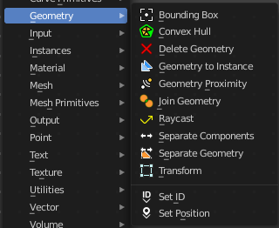
Here you find nodes to modify the geometry.

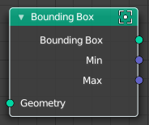
Bounding Box
The Bounding Box geometry node allows you to work with the values of a bounding box.

Inputs

Geometry
Standard geometry input.

Output

Bounding Box
Standard output.

Min
The minimum values of the bounding box.

Max
The maximum values of the bounding box.

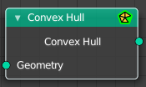
Convex Hull
The node allows you to work with the values of a convex hull of this object.

Inputs

Geometry
Standard geometry input.

Output

Convex Hull
Standard output.

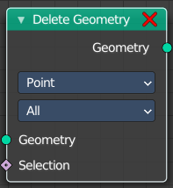
Delete Geometry
The node allows you to work with the values of a convex hull of this object.

Inputs

Geometry
Standard geometry input.

Selection
A selection of the geomerty

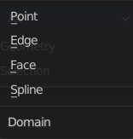
Properties

Domain
What element to delete.

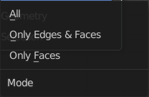
Mode
Delete mode. Names should be self explaining.

Output

Geometry
Standard output.

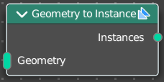
Geometry to Instance
Turns every connected input geometry into an instance. These instances can then for example be used in the Instance on Points node.

Inputs

Geometry
The input geometry.

Outputs

Instances
The output instances.

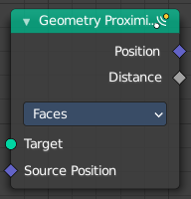
Geometry Proximity
This node finds the closest position on the target for each point in the input geometry.

Inputs

Target
The target object.

Result
Name of the attribute where the output is stored. If the attribute does not exist yet, it is created.

Position
The position where the computed location is stored.

Properties

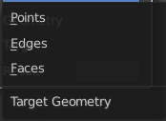
Target Geometry
The element of the target geometry to calculate the distance from.

Outputs

Position
Closest location on the surface of the target mesh, or the closest point in the target point cloud in Points mode.

Distance
Distance from the source position to the closest location in the target.

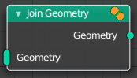
Join Geometry
The Join Geometry enables you to merge separately generated pieces of geometry into a single one. In case that the inputted pieces contain different types of geometry, the output will contain multiple types of geometry.

Inputs

Geometry
Standard geometry input.

Output

Geometry
Standard geometry output.

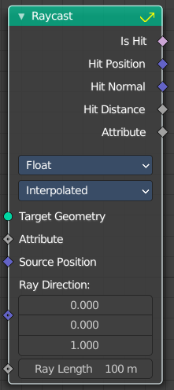
Raycast
This node sends a raycast and retreives data from the hit target.

Inputs

Target Geometry
This is actually the source object that sends the ray.

Attribute
Attribute input.

Source Position
Source position input.

Ray Direction
A vector 3 for the ray direction.

Ray Length
The length of the ray.

Properties

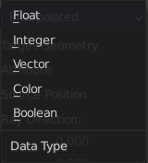
Data Type
What data to calculate on hit.

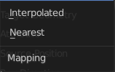
Mapping
Mapping from the target geometry to hit points. Interpolated or nearest.

Output

Is Hit
Has the raycast hit something?

Hit Position
The hit position if any.

Hit Normal
The normal of the hit point.

Hit Distance
The distance of the hit point.

Attribute
The attribute of the hit object.

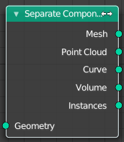
Separate Components
Splits a geometry into its components.

Inputs

Geometry
Geometry input.

Outputs

Mesh
Mesh component of the input geometry.

Point Cloud
Point cloud component of the input geometry.

Curve
Curve component of the input geometry.

Volume
Volume component of the input geometry.
In case that the input contains multiple volume instances, only the first volume component will be calculated.

Instance
The single instances of the geometry.

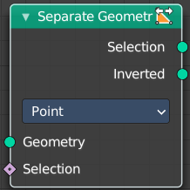
Separate Geometry
Separates a selection of a geometry into its own object.
Tip: when you combine it with the Compare Floats nodem then you get a more precise control of which parts are separated to a given output geometry.

Inputs

Geometry
Geometry input.

Selection
Selection input.

Properties

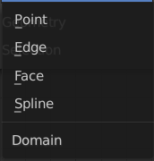
Domain
What kind of geometry to separate.
Note that when selecting a domain that doesn’t modify all components, the unmodified components will appear in both outputs.

Outputs

Selection
Separated selection.

Inverted
The inverted separated selection.

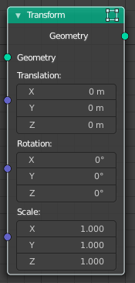
Transform
Move, rotate or scale the geometry. The transformation is applied to the entire geometry, and not per element. For example, you can not rotate individual point cloud points with this node.

Inputs

Geometry
Standard geometry input.

Translation
Translates the geometry in local space of the modified object.

Rotation
Euler rotation in local space.

Scale
Scale to transform the geometries in local space.

Output

Geometry
Standard geometry output.

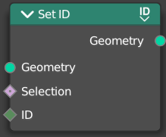
Set ID
Sets the ID of the target geometry.

Inputs

Geometry
Geometry input.

Selection
Selection input.

ID
ID Input

Outputs

Geometry
Geometry output.

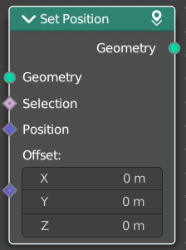
Set Position
The Set Position node controls the location of each point, the same way as controlling the position attribute. If the input geometry contains instances, this node will affect the location of the origin of each instance.
The input node for this data is the Position Node.

Inputs

Geometry
Geometry input.

Selection
Whether or not to change the position of each point or instance. True values mean the position will be changed, false values mean it will remain the same.

Position
The new position for selected elements. By default, this is the same as if the Position Node was connected, meaning the node will do nothing.

Offset
An optional translation for each point. This is evaluated at the same time as the Position input, meaning that fields evaluated for it will not reflect the changed position.

Outputs

Geometry
Geometry outputs.

Legacy - Geometry

These nodes existed in a former Bforartists version, but are now deprecated. They do not show in the regular menu or UI anymore. And you cannot insert them in a newer Bforartists version. But old projects that uses this nodes still loads with these nodes showing and enabled.

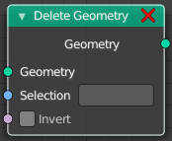
Delete Geometry
Allows to delete geometry.

Inputs

Geometry
Standard geometry input.

Selection
A selection of a geometry.

Invert
Invert the selection of the geometry.

Output

Geometry
Standard geometry output.

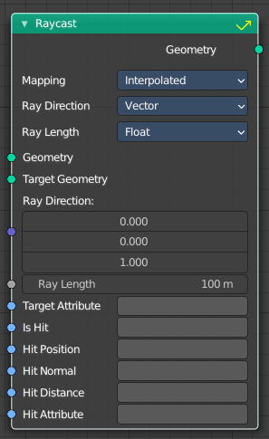
Raycast
Casts rays from one geometry to another. When the ray hits something within its maximum ray length, then you can retreive several different data sets.
Hit Position, Hit Normal and Hit Distance are the properties of the target mesh at the intersection point. Additionally a Target Attribute can be specified that is interpolated at the hit point and the result stored in Hit Attribute.

Inputs

Geometry
Rays are created at the geometry points.

Target Geometry
Geometry that rays are tested against.

Ray Direction
Direction of each ray from the starting position.

Ray Length
Maximum distance a ray can travel before being considered „no hit“.

Target Attribute
An optional attribute of the Target Geometry that will be interpolated at the hit points. The resulting values are stored in the output attribute named by Hit Attribute.

Is Hit
Boolean output attribute that is true for each ray which has hit the Target Geometry.

Hit Position
Output attribute storing the intersection point with the target mesh.

Hit Normal
Output attribute storing the surface normal vector at the hit location.

Hit Distance
Output attribute storing distance from the ray origin to the hit point.

Hit Attribute
Output Attribute storing interpolated values of the Target Attribute at the hit positions.

Properties

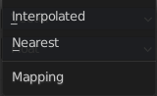
Mapping
How the attributes of the target mesh are mapped to the attribute values on the result geometry.

Nearest
uses the atribute from the nearest geometry.

Interpolated
uses the attribute from the corners of the hit face.

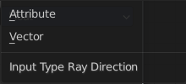
Ray Direction

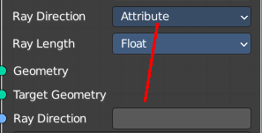
Attribute
Use an attribute instead of a vector for the ray direction.

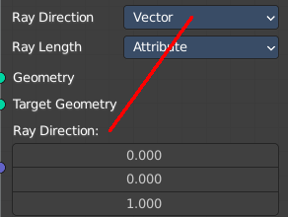
Vector
Use a vector for the ray direction.

Ray Length

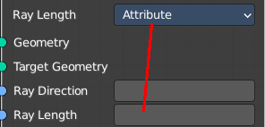
Attribute
Use an attribute instead of a float value for the ray length.

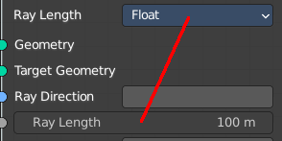
Vector
Use a float value for the ray length.

Outputs

Geometry
The geometry that contains output attributes for each ray.

